SIMATS ENGINEERING (SAVEETHA SCHOOL OF ENGINEERING)
Department of Computer Science and Engineering

ASSESSMENT TOOL 2 – SCENARIO BASED ASSESSMENT (3 Questions)

Course Code: | DSA06 | Course Title: | Data Handling and Visualization
CO Assessed: | CO5 – Precision (BL6) | Assessment: | Assessment Tool 2 – Scenario Based Assessment
Weightage: | 20% of CIA | Total Marks: | 30 (3 Questions × 10 Marks)
CO5 Statement: | Create effective and interactive visualizations by integrating data wrangling and advanced visualization tools (BL6)
Student Name: | JANI DILIP | Reg. No.: | 192424314
Section / Batch: | B-TECH (AI & DS) | Date: | 18-08-2026

Code of Conduct
I JANI DILIP (192424314) certify that this submission is my original work and that I have adhered to the guidelines specified for this assessment. I understand that any violation of academic integrity rules will result in disciplinary action.
Signature of the Student: 
Instructions
- This test contains 3 questions, each carrying 10 marks. Total: 30 Marks.
- No negative marking. Unanswered questions carry zero marks.
- No calculators or electronic devices permitted.
- Duration: 60 minutes.
Section / Topic | Focus Area | Q. Nos. Marks
Visualizing Uncertainty | Probability visualization, confidence intervals, uncertainty interpretation | 1 | 1
Handling Overplotting | Overplotting, transparency, jittering, alternative plots | 2 | 1
Principles of Effective Visualization & Accessibility | Proportional ink principle, misleading axes, accessible color design | 3 | 1
 | GRAND TOTAL: | 30 Marks

Annexure A – Scenario Based Assessment

- A weather forecasting agency predicts rainfall probability (%) for a week along with uncertainty:
Day | Rainfall Probability | Confidence Interval
Mon | 60 | 10
Tue | 65 | 20
Wed | 70 | 5
Thu | 55 | 15
Fri | 80 | 25
As a data analyst, design a visualization that clearly communicates both probability and uncertainty. Which day’s prediction is most reliable? Justify your answer using visualization principles.

- A mobile app company collects user ratings (1–5) from 500 users. Many users give the same ratings:
Rating | Frequency
1 | 50
2 | 80
3 | 150
4 | 140
5 | 80
If plotted directly, the visualization suffers from overplotting. Propose a suitable visualization technique and explain how transparency or jittering can improve clarity. Suggest an alternative plot if needed.

- A company presents employee satisfaction scores:
Department | Score (%)
HR | 70
Sales | 75
IT | 78
Finance | 80
The chart uses a truncated y-axis (starting at 65) and red-green color coding.
Identify the issues in this visualization. Redesign it using proper axis design, proportional ink principle, and accessible color choices. Explain how your design avoids misleading interpretation.
Faculty In-charge | Course Coordinator | Head of Department
Signature: _______________ | Signature: _______________ | Signature: _______________
Date: ___________________ | Date: ___________________ | Date: ___________________

Rubrics for Calculation

Criteria | Weig  htage  (%) | Level 4 (Exemplary) | Level 3  (Proficient  ) | Level 2 (Developing) | Level 1 (Beginning) | Marks
Understanding of Scenario | 20% | Demonstrates clear and complete understanding of the scenario and context | Shows good understand ing with minor gaps | Partial understanding ; misses key aspects | Misinterprets or fails to  understand the scenario
Identification of Key Issues | 20% | Accurately  identifies all relevant issues and factors involved | Identifies most key issues with minor omissions | Identifies limited issues; some  irrelevant points | Unable to identify key issues
Application of  Concepts | 25% | Applies appropriate concepts  effectively to address the scenario | Applies concepts with minor errors | Limited or partially correct application | Unable to apply relevant concepts
Decision Making | 20% | Makes wellreasoned, logical decisions with strong rationale | Makes reasonable decisions with some  justification | Makes weak  decisions with limited justification | No clear decisions made or rationale provided
Clarity of  Response | 15% | Response is clear, structured, and  logically  presented | Generally clear with minor issues | Somewhat  unclear or poorly structured | Disorganized  and difficult to understand

1. Rainfall Probability with Uncertainty
Given Data
Day | Rainfall Probability (%) | Confidence Interval
Monday | 60 | ±10
Tuesday | 65 | ±20
Wednesday | 70 | ±5
Thursday | 55 | ±15
Friday | 80 | ±25

An error bar chart is used to show a measured or estimated value together with its uncertainty.
- The point represents the rainfall probability.
- The error bar represents the confidence interval/uncertainty.
- A shorter error bar means the prediction is more precise.
- A longer error bar means greater uncertainty.
Important Points
- Monday = 60% ± 10%
- Tuesday = 65% ± 20%
- Wednesday = 70% ± 5%
- Thursday = 55% ± 15%
- Friday = 80% ± 25%
Reliability
Wednesday is the most reliable prediction because it has the smallest uncertainty (±5%).
Its estimated range is:
[70%-5%=65%]
to
[70%+5%=75%]
So, Wednesday's prediction lies between 65% and 75%.
Conclusion
The error bar chart is the best choice because it displays both the probability and uncertainty in a single graph. Wednesday is the most reliable prediction because its error bar is the shortest.
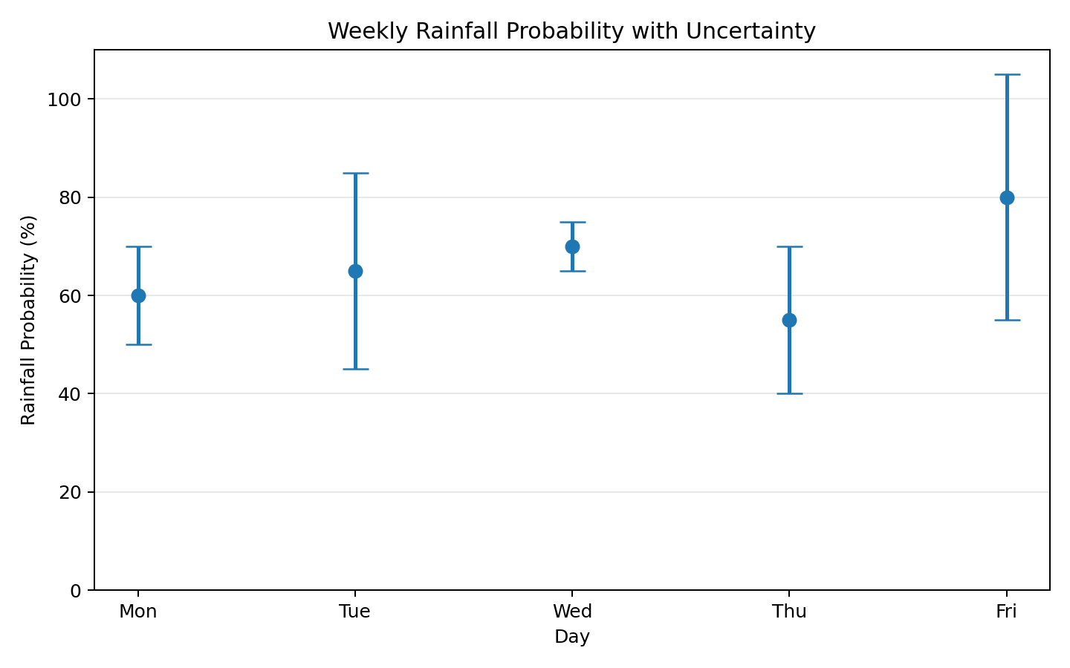

2. Mobile App User Ratings
Given Data
Rating | Frequency
1 | 50
2 | 80
3 | 150
4 | 140
5 | 80
Total users = 500

Overplotting occurs when many observations are plotted at the same position and overlap each other.
Since many users have the same rating, plotting all observations directly can hide individual data points.
Jittering
Jittering means adding a small random displacement to the points.
Instead of putting all rating-3 observations at exactly the same position, the points are slightly spread around the rating value.
Transparency
Transparency makes individual points partially visible.
- Low transparency → overlapping points become darker.
- It helps identify areas where many observations are concentrated.
- It prevents points from completely hiding one another.
Important Points
- Rating 3 → 150 users
- Rating 4 → 140 users
- Rating 2 → 80 users
- Rating 5 → 80 users
- Rating 1 → 50 users
Therefore, rating 3 is the most common rating.
Alternative Visualization
A bar chart can also be used because the data already provides frequency for each rating.
A bar chart is simpler when the objective is only to compare frequencies.
Conclusion
A jitter plot with transparency is useful when individual observations need to be displayed without ecessive overlap. A bar chart is a good alternative for showing only the frequency distribution.
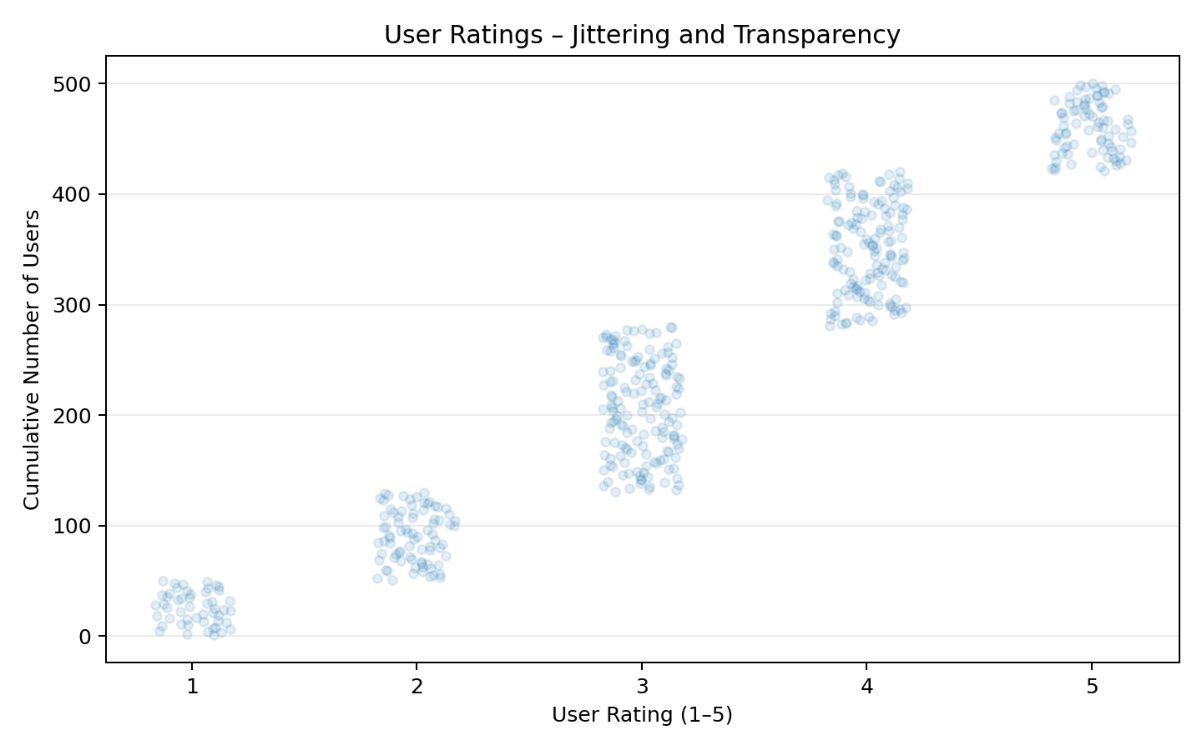

3. Employee Satisfaction Scores
Given Data
Department | Satisfaction Score
HR | 70%
Sales | 75%
IT | 78%
Finance | 80%
Problems in the Original Visualization
1. Truncated Y-axis
The original graph starts at 65% instead of 0%.
This can make the differences between departments appear much larger than they actually are.
For example:
- HR = 70%
- Finance = 80%
Actual difference:
[80-70=10%]
But if the graph starts at 65%, the visual difference can appear extremely large.
2. Red-Green Color Coding
Using red and green can create accessibility problems for people with red-green color vision deficiency.
Also, color should not be the only method of communicating information.

A bar chart is appropriate for comparing satisfaction scores across departments.
The redesigned graph:
- Starts the Y-axis at 0%.
- Uses equal intervals.
- Clearly labels the axes.
- Avoids unnecessary decoration.
- Uses a simple, accessible visual design.
- Represents the magnitude proportionally.
Proportional Ink Principle
The proportional ink principle means that the visual size of a graphical element should accurately represent the numerical value.
The visual heights should follow the same relationship.
Accessible Color Choices
Instead of relying on red and green:
- Use blue and orange if multiple categories need different colors.
- Use labels and values along with colors.
- Use patterns or different shapes when necessary.
- Ensure sufficient contrast.
Interpretation
- Finance has the highest satisfaction = 80%.
- IT = 78%.
- Sales = 75%.
- HR has the lowest = 70%.
The actual difference between HR and Finance is only 10 percentage points, and the redesigned graph represents this without exaggerating the difference.
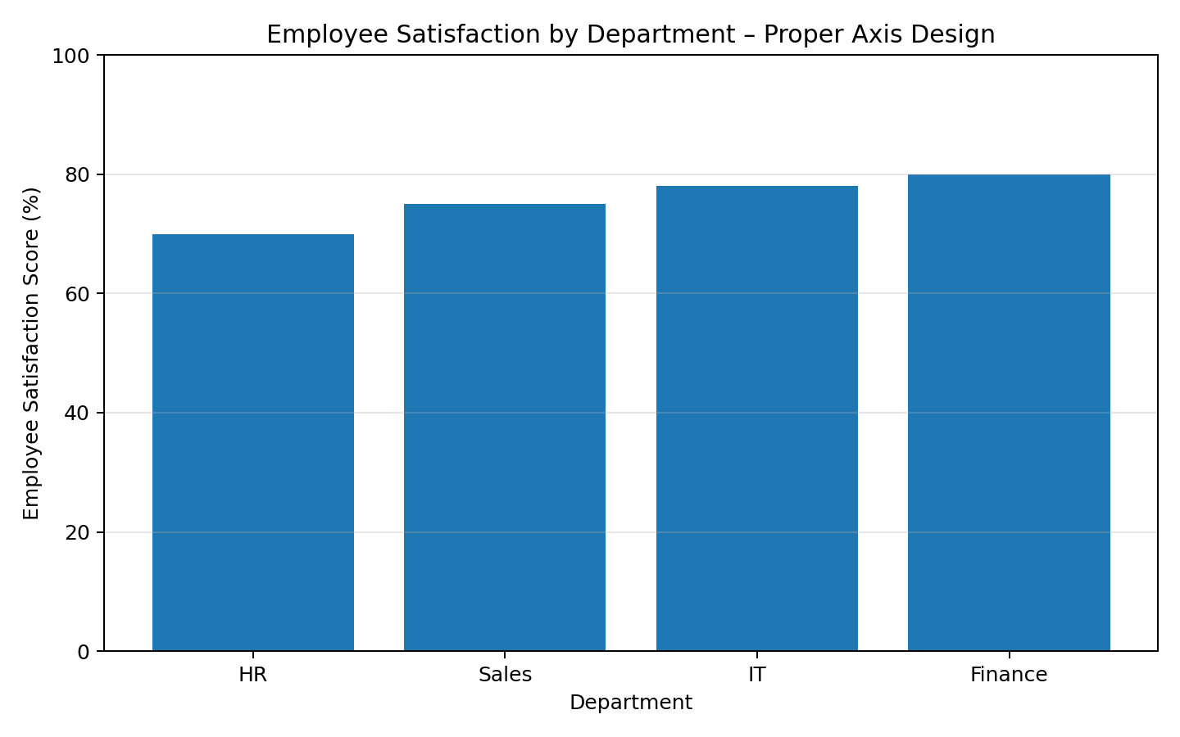

Final Conclusion
The redesigned visualization avoids misleading interpretation by using a proper 0–100% Y-axis, proportional bars, clear labels, and accessible color choices instead of relying on red-green coding.

